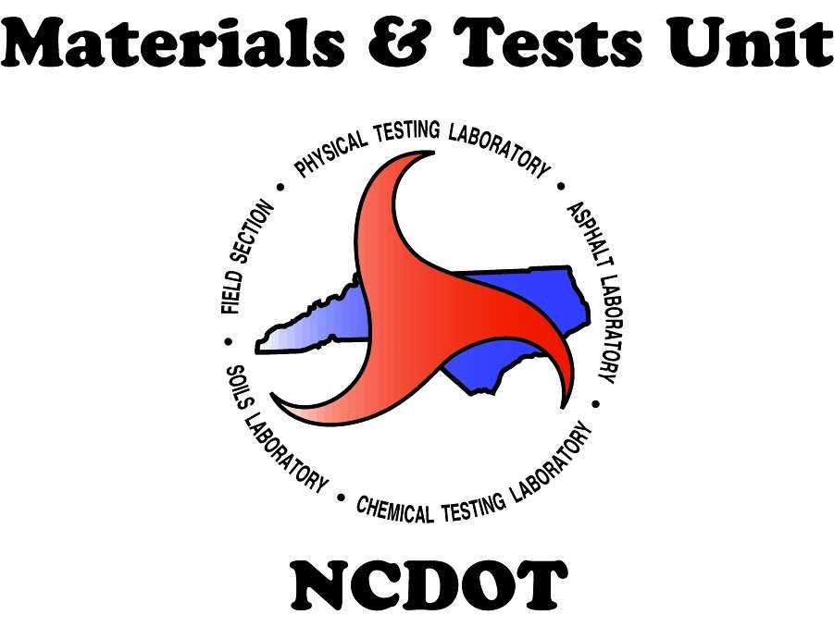
Approval Process
For A New Ready Mixed Concrete Facility

The following process is intended for Ready Mixed Concrete producers who are requesting to supply structural and incidental concrete to NCDOT projects and are not currently on the “NCDOT Approved Producer List”. This process is also applicable for facilities which may have been removed from the approved list more than three months and request re-approval.
This process does not apply to PCCP, Precast, Prestress, or Volumetric operations.

- Each Ready Mixed Concrete producer is responsible for successfully passing a third-party inspection. This third-party inspection is conducted by the National Ready Mixed Concrete Association (NRMCA). The following link can be utilized to find an approved NRMCA inspector in the local area:
https://www.nrmca.org/certifications/plant-and-truck-certification-program/. The producer’s quality control manager shall contact NRMCA and request this inspection.
- During the third-party inspection, the NRMCA inspector must conduct the “NCDOT Addendum”. The producer must meet all required sections successfully to be approved.

- Upon successful completion of the 3rd party inspection, the producer’s quality control manager shall submit all documents to NRMCA for final approval.

- After the producer’s quality control manager requests the third-party inspection, the producer’s certified Mix Design technician shall submit individual concrete mix designs for Pre-approval. These mix designs shall be sent via email to: Concretedesigns@ncdot.gov. When submitting for a new facility, the Ready Mixed Concrete Facility number (RM#) will be noted as “New Facility”. An RM# will be granted after the final registration of the facility.
- The producer’s quality control manager shall complete the “Ownership Form”.
- The Ready Mixed Concrete’s facility representative shall contact the local Material & Tests Unit’s Section Materials Specialist (SMS) and request an M&T Facility Audit for the new facility.

- The SMS shall schedule and conduct the M&T Audit on the facility. Additionally, the SMS shall collect representative samples for all materials based on the pre-approved mix design(s).

- The SMS shall inform the facility representative of sample results obtained during the facility audit.

- The facilities’ representative shall submit a complete package of 3rd party inspection documentation (approved and signed by NRMCA and also signed Certificate by the plant officials), “NCDOT Addendum” and “Ownership Update Form” via email to readymixinspections@ncdot.gov.

- The SMS shall submit the M&T Facility Audit Report via email to readymixinspections@ncdot.gov.
- When the Ready Mixed Concrete facility meets all the above operations/requirements, the facility will be registered in the NCDOT Vendor system as an approved concrete producer/supplier. A notification will be emailed to the facility recognizing the approval status and include an RM#. This RM# shall be noted on all documentation relating to future NCDOT business.
- The facility’s representative shall inform the RM# to Concretedesigns@ncdot.gov for the final approval of the Mix Design(s).

